1. **What is software? What is software engineering?**

Software is a set of instructions, data or programs used to operate computers and execute specific tasks.

-just like human language.

**🡪 What is software engineering?**

―Software engineering is the art of developing quality software on time and within budget.

-Software Engineering is a systematic approach to the design, development, operation,

and maintenance of a software system.

**2. Explain Types of software.**

-Software can be categorized into 3 types:

1) System Software:

This includes the operating system and all the utilities

that enable the computer to function.

Ex: Windows, macOS, Linux

2) Application Software:

These are the programs that help user to perform specific tasks.

Ex: Word Processors, web browsers and games.

3) Middleware:

that connects different systems or applications. It enables

communication and data management for distributed applications.

**3. What is SDLC? Explain each phase of SDLC.**

-SDLC stands for Software Development Life Cycle.

- it is a process used by software engineers and developers to design, develop, test and deploy high-quality software systematically and efficiently.

-the SDLC involves several phases.

**1. Requirements gathering and analysis:**

-Gathering maximum information from the client requirements for the product.

-Discuss each detail and specification of the product with the customer.

-the development team then analyse the requirements keeping the design and code of the

Software in the mind.

**2. Design:**

-this is the stage where a web developer or front-end developer comes in, who creates

Designs for application or software that make the software appealing and easy to use.

**3. Implementation:**

-it means translating the design to a computer-legible language.

-in this phase of SDLC, the tasks are divided into modules or units and assigned to

Various developers.

-The developers will then start building the entire system by writing code using the programming languages they chose.

- this stage is considered as the longest in SDLC.

**4.Testing:**

- Once the developers build the software, then it is deployed in the testing environment.

-then the testing team tests the functionality of the entire system.

-the testing is done to ensure that the entire application works according to the customer requirements.

-After testing, the testing team might find some bugs and then the development team fixes the bugs and send it to for a retest.

-this process goes on until the software is stable and bug-free.

**5. Maintenance:**

-the actual problem starts when the customer actually starts using the developed system

And those needs to be solved from time to time.

-maintenance is the seventh phase of SDLC where the developed product is taken of.

-According to the changing user end environment or technology, the software is updated timely.

**4. What is DFD? Create a DFD diagram on flip cart.**

-A Dats Flow Diagram is a graphical representation of the flow of data within a system.

-it illustrates how data is processed by a system in terms of inputs and outputs.

-DFDs are used to understand and analyse the flow data through systems, showing how data enters, leaves, and moves through processes.

**🡪 flipcart DFD diagram.**

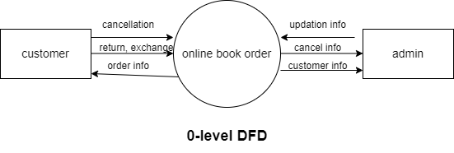

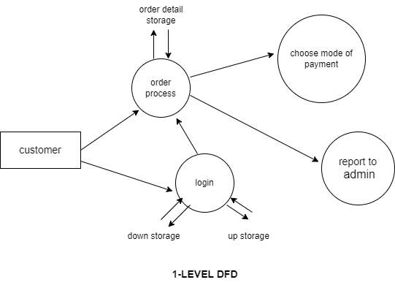

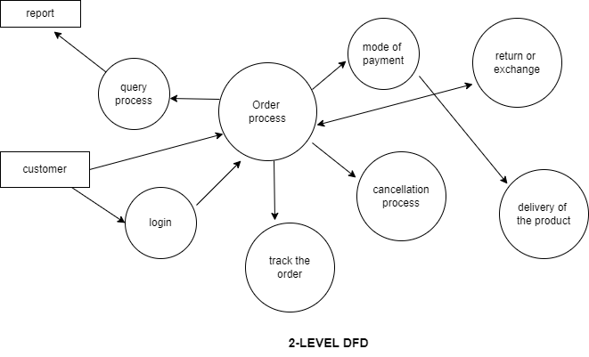

**5. What is Flow chart? Create a flowchart to make addition of two number.**

**Flowchart**

-A flowchart is a type of diagram that represents a workflow or process. A flowchart can also be defined as a diagrammatic representation of an algorithm.

**Algorithm**:

-A set of rules that must be followed when solving a particular problem.

#include<stdio.h>

Int main()

{

Int no1, no2, answer;

Printf(“enter the numbers”);

Scanf(“%d%d”, &no1,&no2);

Ans=no1+no2;

Printf(“the ans is %d”,ans);

Return 0;

}

**-Algorithm:**

1)start

2)declare n1, n2, answer

3)display message enter 2 values

4)read values of n1 and n2

5)ans=no1+no2

6)display answer

7)stop

**-Flowchart**

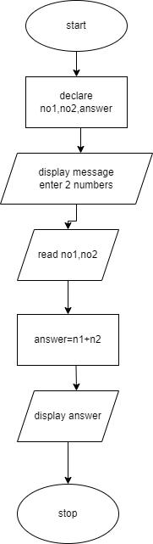

**6.What is Use-case diagram? Create a use-case on bill payment on paytm.**

**🡪Use-case diagram.**

-Use-case diagram illustrate and define the context and requirements of either an entire system or the important parts of the system. You can model a complex system with a single use-case diagram, or create many use-case diagrams to model the components of the system.

**-Use-case diagram on paytm.**

